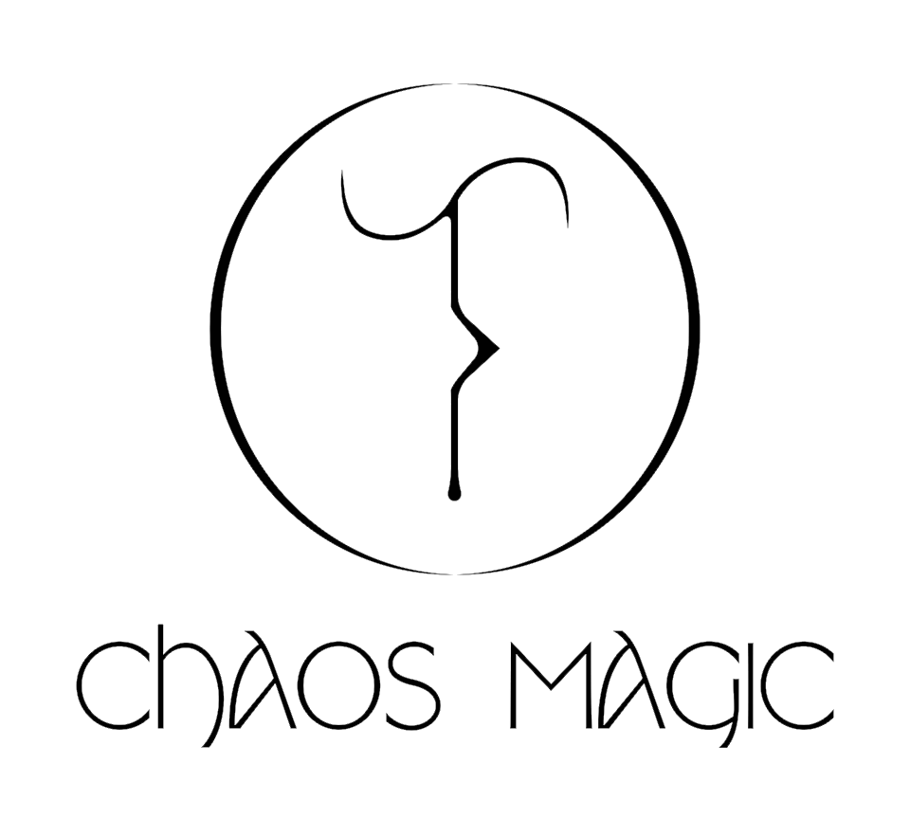

We are looking for new Chaos Magic members!

Chaos Magic is an artist led project space based within BACKLIT in Nottingham. The studio is a shared, open plan space with an adjoining, purpose built gallery. We are looking to recruit new blood…
​
We focus on collaboration, community and learning producing newly commissioned artwork, live performances, gardening, growing food, talks, readings, workshops and publishing.

Since launching in October 2018 we have held events and exhibitions that aim to use the principles of the Chaos Magick practice as a base for our programming. Using the idea that reality has the power to be controlled and potentially changed, our programme covers a broad spectrum of interests within art, spirituality, ecology, society, science and technology.
​
Chaos Magic consists of six artists: five recent graduates and one established mentor. Five current members are recent graduates developing their practice and curatorial skills at Chaos Magic.
​
We want to give opportunities to early career artists and more established researchers who have interests in running an art space and programming events, whilst also supporting the Nottingham art scene.

The 'Chaos Magic Graduate Member' position is open for early career artists working in any creative practice, graduating from within the past 5 years.
​
The 'Chaos Magic Programmer and Mentor' position is open for curators, artists and researchers with some experience of organising and producing art events and exhibitions, as well as an interest in supporting graduating members in their development.
​
This developmental opportunity is for a period of one year, allowing members to change on an annual basis. Rent is £69/month and the new members would be expected to join Chaos Magic by 1st May 2020.

If you are interested please complete the application form below and attach 5 images of your work (jpeg/PDF). Please send your application to by 15th March 2020.
Application Form

Name: ____________

Current city of residence: ____________

Which position are you applying for? ____________

Tell us about your art practice. (Max 200 words)

Tell us about any art & design education you may have completed, any relevant experience you have undertaken, and any previous history of running an art space. (Max 200 words)

Why are you interested in becoming a member of Chaos Magic? (Max. 200 words)

Give an example of an event, exhibition, or workshop that you would like to run. (Max 200 words)

